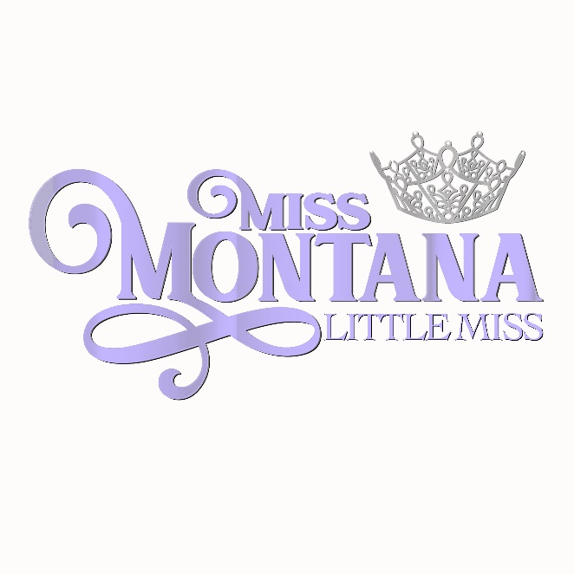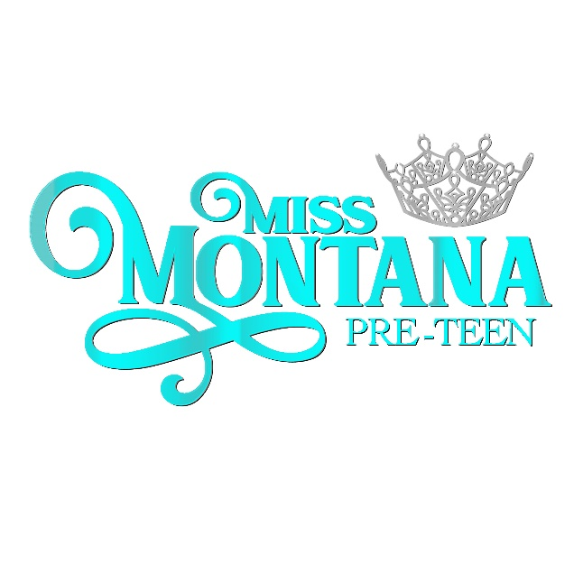

2023 State Contestant Application
There are two ages divisions. Ages 8-10 will compete for the title of Miss Montana Little Miss while ages 10½-12 will compete for the title of Miss Montana Pre-Teen. Contestants who turn 10 on, or before, December 31, 2022, will compete in the Pre-Teen age division.
(Please type or use legible Handwriting)

Name _____________ __________T-Shirt Size_________

Age Division competing in: (Circle One)

Little Miss (8-10 ½)
Pre-Teen (10 ½-12)

Hometown Date of Birth

Parents’ email address

Address (including city) ______

Parents’ Names

Parents’ Address

Parents’ Home Phone

Cell Phones

$350 Entry Fee Sponsor/Sponsors (up to 3 sponsors):

__________________________________________________________________________________

PARENT SIGNATURE Date

Mail application to:
MMVP
ATTN: Little Miss/Pre-Teen Application
PO Box 504
Glendive, MT 59330

All contestants must have a high-quality headshot of head and shoulders, No full length photos.
Please send official headshot in color to: holdenmissmt@gmail.com

Girls will compete in the following Areas of Competition:
Private Interview
Activewear
On-Stage Question
Evening Wear

There will also be an optional talent competition. This is a stand alone competition.

They are allowed to get up to 3 sponsors for their $350 entry fee, those sponsors will have logos listed in the program book on the contestant’s page. The sponsor can use the donation for advertising. Contestants will not be accepted until sponsor fee is received. At the time of acceptance, contestant will be emailed a Contestant Profile to be filled out. This profile will be given to the judges, so please make sure it is typed. Sponsor logos have to be emailed to holdenmissmt@gmail.com as soon as you can.

Girls will need to be able to come to Glendive Wednesday through Saturday of program week. Girls are required to be present at all three nights of competition, Thursday, Friday, and Saturday. Complete schedule will be sent out as we get closer to Competition.

Both age division winners will receive a crown, sash, $350 scholarship and entry fee to be a National Princess at the Miss Volunteer America Pageant.

If you have any questions, please feel free to contact Jan @ holdenmissmt@gmail.com or by phone at 406-939-5708.

